
INVITATION TO SUBMIT PRICE QUOTATION FORM
The Provincial Government of Davao del Norte, through its Bids and Awards Committee (BAC) invites suppliers/manufacturer/distributors/contractors to submit Price Quotation for the following:
PQF NO. | PR No. | Name of Project/s | R.O. | ABC
C20170353 | 1702-0665 | Gardening Tools for Integrated Mgt. of Fusarium Wilt of Bananas in the Phil. | PAGRO | 73,955.00
C20170356 | 1702-0661 | 1,600 pcs. Leaflets for DA Management of Banana Fusarium Wilt in DDN | PAGRO | 80,000.00
C20170357 | 1702-0663 | 1 unit Wall Mounted Airconditioner, Split type for DA Agri-Pinoy Rice Achievers Awards | PAGRO | 59,058.98
C20170359 | 1702-0670 | Drugs & Medicines for Leprosy Control Activity of PHO-DDN | PHO | 114,400.00
C20170364 | 1703-0690 | Hardware Materials for improvement of Media Center | PGSO | 104,402.00
C20170375 | 1703-0707 | 42 units Anti Virus Software License for use of PTO | PTO | 63,000.00
C20170377 | 1703-0708 | IT Equipment for use of PTO | PTO | 170,000.00
C20170381 | 1703-0710 | Medical Oxygen for use of DDN Hospital Samal Zone | SDH | 124,500.00
C20170388 | 1702-0512 | Hardware Materials for Fishery Agri-Aquaculture Enhancement Project | PAGRO | 126,220.50

The complete schedule of the activities is listed, as follows:
ACTIVITY | DATE/S
1. Issuance of Price Quotation Forms | March 10, 2017 – March 15, 2017  Procurement Planning & Purchasing Section, 2nd Floor, PGSO Bldg. Government Center, Mankilam,Tagum City, DDN
2. Opening of Shopping & Small Value Procurement | March 16, 2017, 09:00 A.M.  PGSO Conference Room¸2nd Floor, PGSO Bldg. Government Center, Mankilam,Tagum City, DDN

Shopping Form may be secured / obtained at the BAC Secretariat, 2F PGSO Building, Government Center, Mankilam, Tagum City, Davao del Norte.

BAC 2017-03-08 | ATTY. EDD MARK O. WAKAN  Provincial General Services Officer  BAC-Chairman
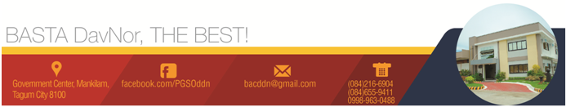
Date of Publication: March 10, 2017

